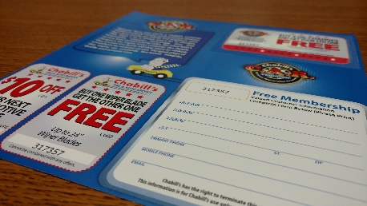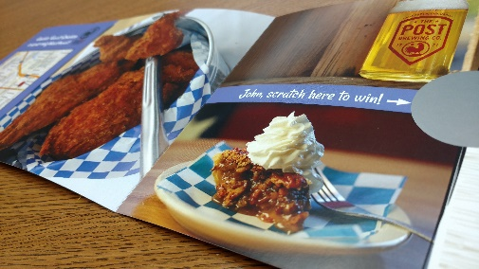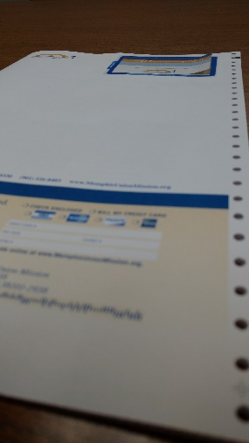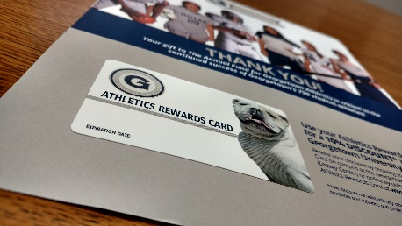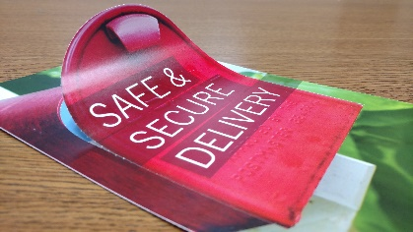****

523 S. Meyer Ave. Valmeyer, IL 62295

800-851-4460 www.margraphics.com

**UV Offset Web Press Cylinder Sizes and Repeats…**

|  |  |  |  |  |
| --- | --- | --- | --- | --- |
| **Cylinder size** | **Max # Colors** | **Recommended Max Coverage** | **Available Repeats** | **Misc.** |
| 14” | 8 | Medium | 3 1/2, 7, 14 |  |
| 17” | 8 | Med up to 8, Heavy to 5 | 4 1/4, 5 2/3, 8 1/2, 17 |  |
| 21” | 4 | Medium | 7, 10 1/2, 21 | 1 cross perf |
| 22” | 10 | Heavy | 5 1/2, 7 1/3, 11, 22 |  |
| 24” | 5 | Medium | 4, 6, 12, 24 | 1 cross perf |
| 28” | 10 | Heavy | 3 1/2, 7, 9 1/3, 14, 28 |  |

**Production notes**

* All presses equipped with inter-stage UV dryers
* All UV offset print produced at 200 line screen, 2400 dpi
* We do not recommend heavy coverage on 14", 17" (if more than 5 colors), 21' and 24" repeats
* Pattern perf from mag die available on 14", 17", 22" and 28"
* Paper from 50# Offset to 9pt coated or uncoated available on web presses
* We do not recommend printing 9pt or heavier w/ tight register on 17" if more than 5 colors
* 40" and 50" O.D. rolls available
* All presses 20.5” max paper width, 20” max print width

**Tech Talk: *UV Offset Web Press Print Sizes***

**MAR can also print UV spot varnish and full varnishes in-line as well as**

**integrate or affix coupons, cards, stickers, decals, labels*, …and much more!***